**PART II: NETWORK**

1. **Staking: Explore staking-related operations.**

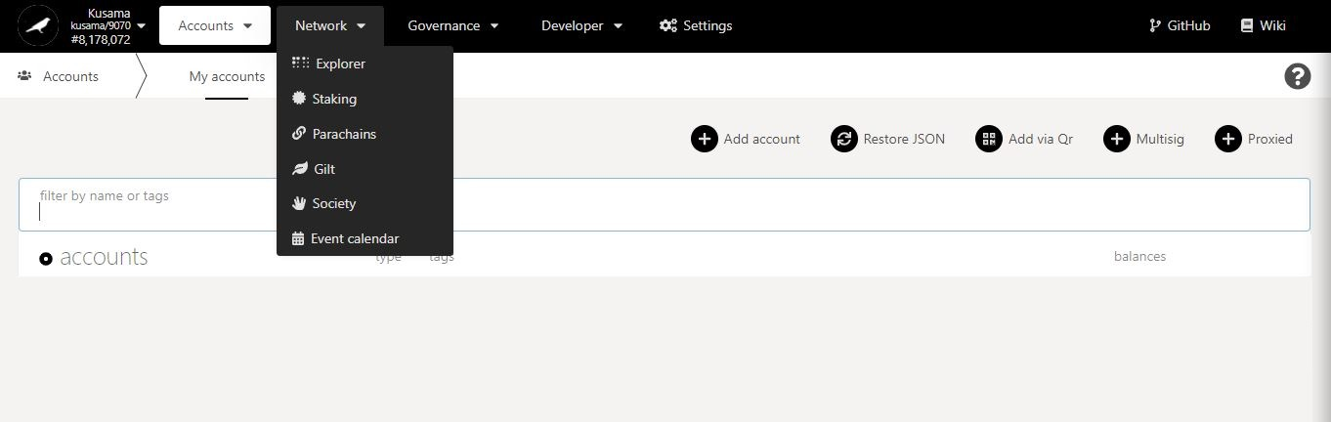

**Basic information on technical words** used in the STAKING section.

* 1. **View general staking information.**

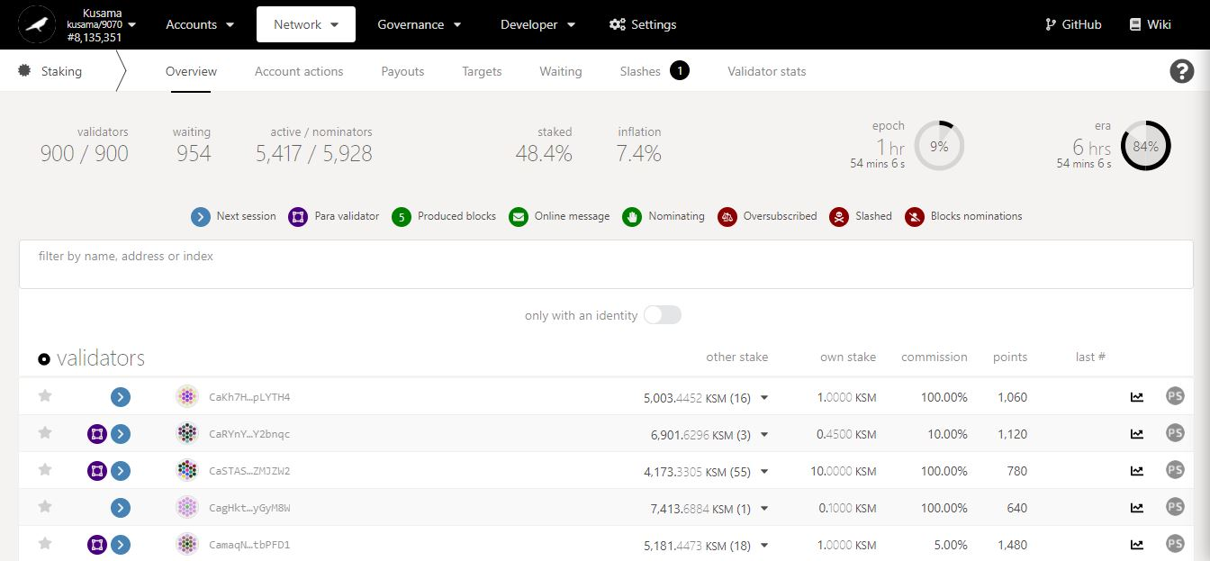

Key information on **validators, nominators and staking statistics.**

Countdown to the **inclusion of new nominators into the list of rewardees**.

Summary of **validators’ balances, commissions, and performance.**

Addresses of **currently elected validators**.

**NEVER SEND YOUR KSM TO A VALIDATOR’S ADDRESS!**

* 1. **Manage account nominations:**
* **Set nominators.**

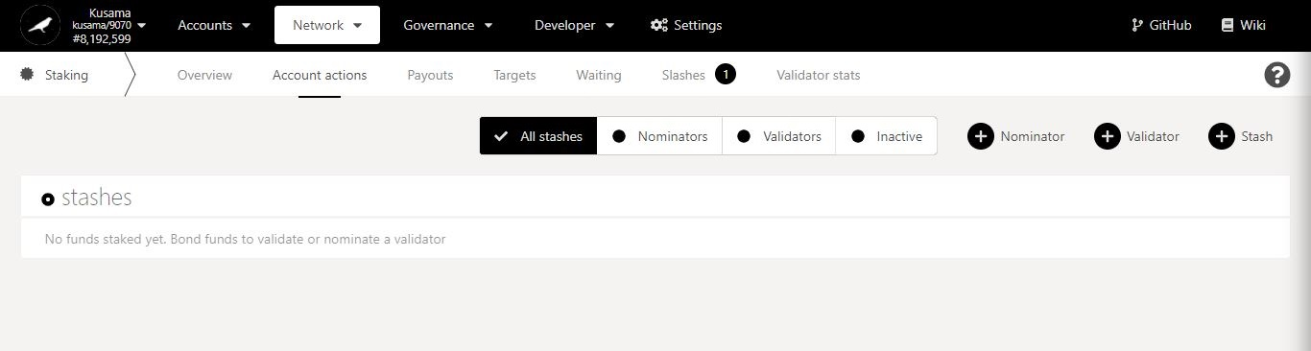

1. Click **Nominator**.

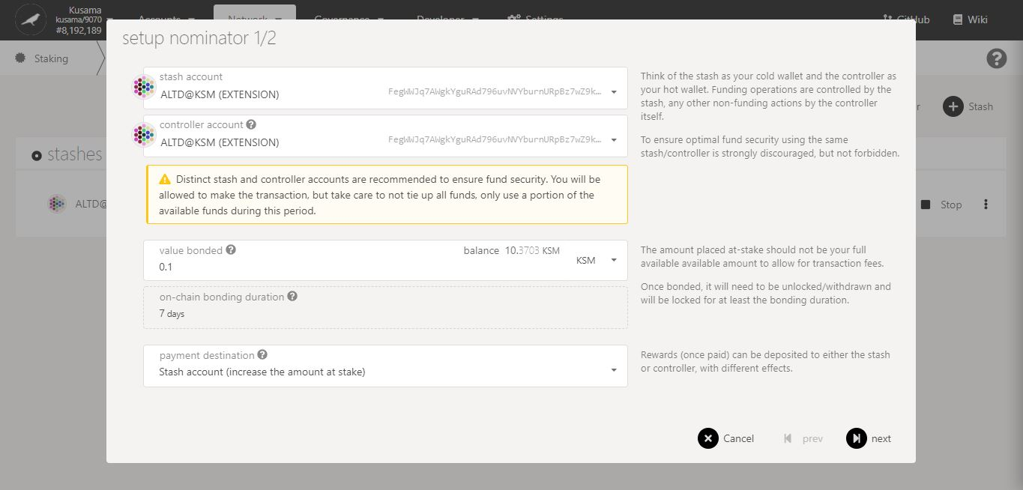

2. Follow **on-screen instructions** carefully.

3. Double-check **warning messages.**

**[Troubleshooting 1/4]**

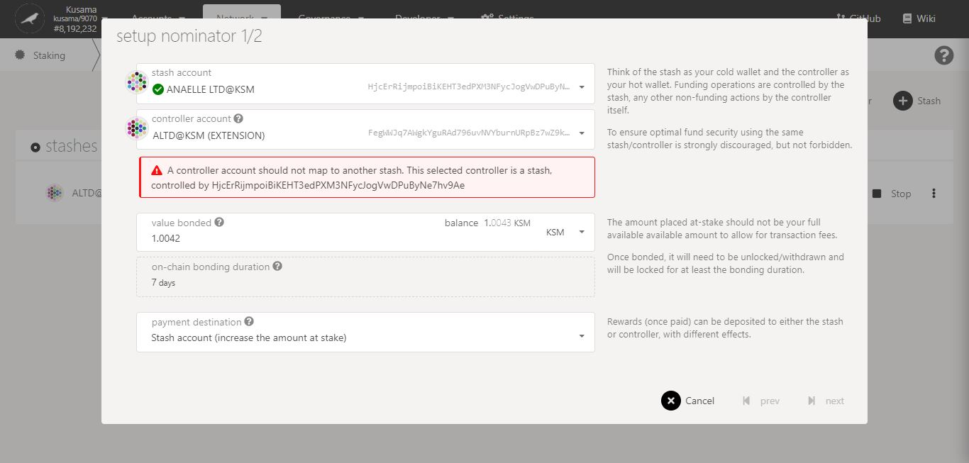

Issue:

You are trying to **use an existing stash as a controller for your new stash**!

Possible solution(s):

- Make the new stash and its controller identical.

- Create a new Polkadot-JS account and set it as the controller to the new stash.

Double-check **error messages.**

**[Troubleshooting 2/4]**

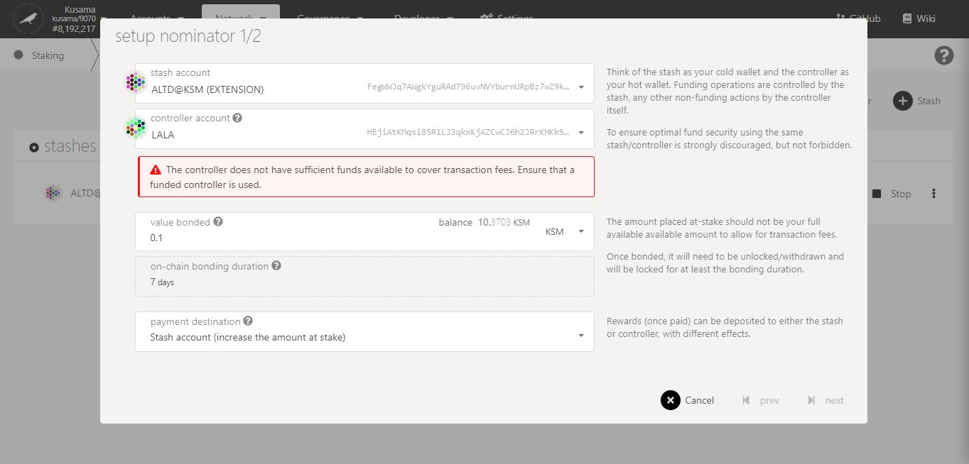

Issue:

Your chosen controller **does not have enough KSM to pay for the transaction fees!**

Possible solution(s):

- Add more funds to your chosen controller’s balance.

- Use a different controller that has a sufficient KSM balance.

Double-check **error messages.**

**[Troubleshooting 3/4]**

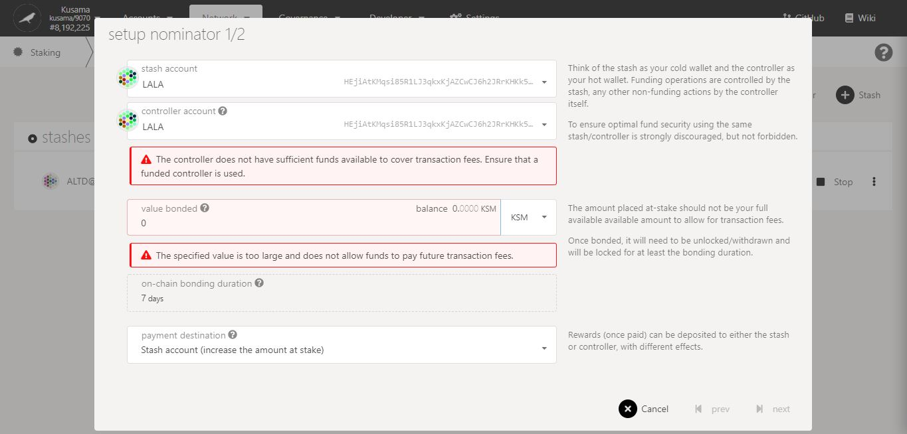

Issue:

Your stash and controller **do not have enough KSM to bond for the nominations and to pay for the transaction fees**!

Possible solution(s):

- Add more funds to your stash balance and controller balances. Note: A minimum of 0.1KSM is needed to nominate.

- Bond more funds into a pre-existing stash that has a some spare KSM.

Double-check **error messages.**

**[Troubleshooting 4/4]**

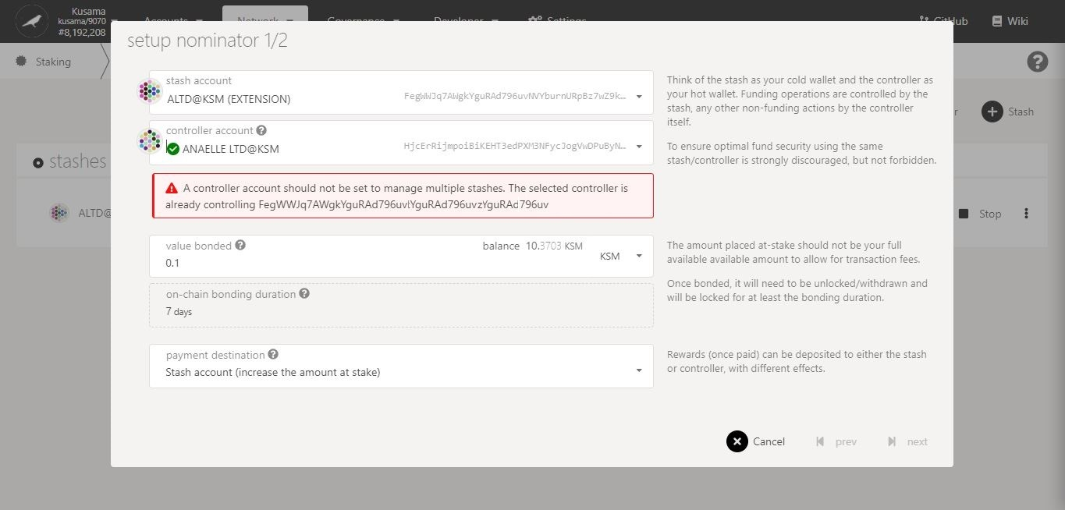

Issue:

You are trying to **use one controller for many stashes**!

Possible solution(s):

- Make the new stash and its controller identical.

- Create a new Polkadot-JS account and set it as the controller to the new stash.

Double-check **error messages.**

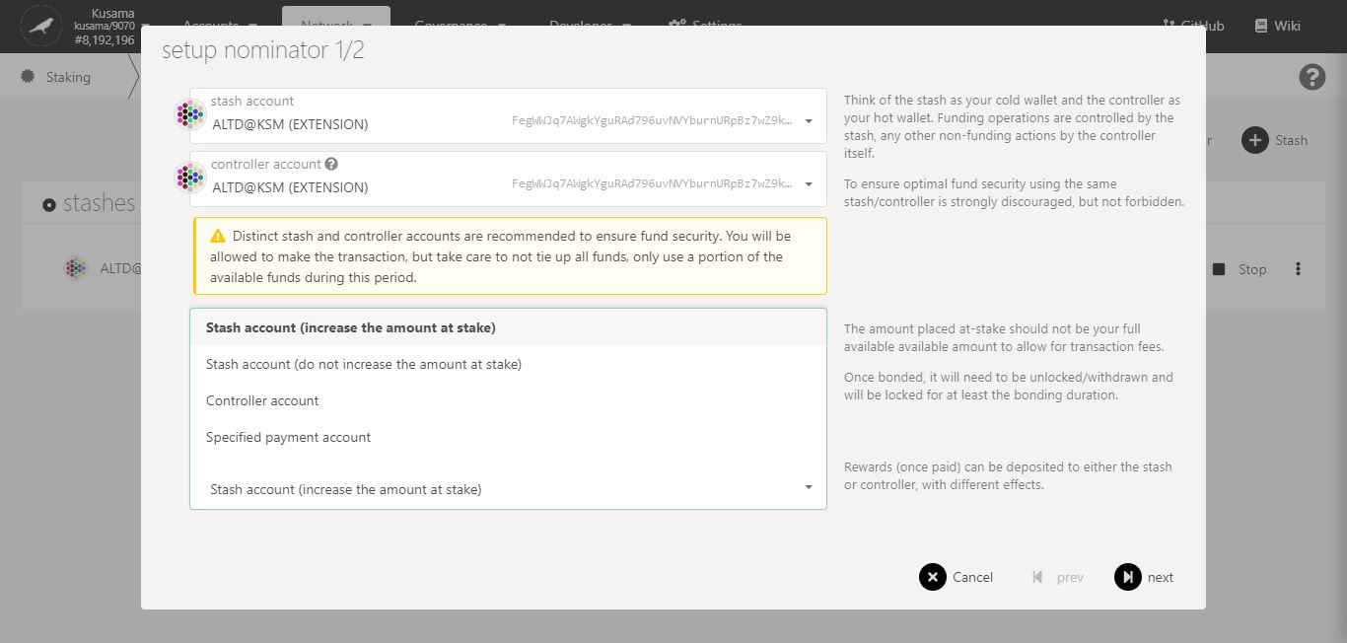

4. Select **one** option for **receiving reward payouts**.

5. Click on **Next** to continue the procedure.

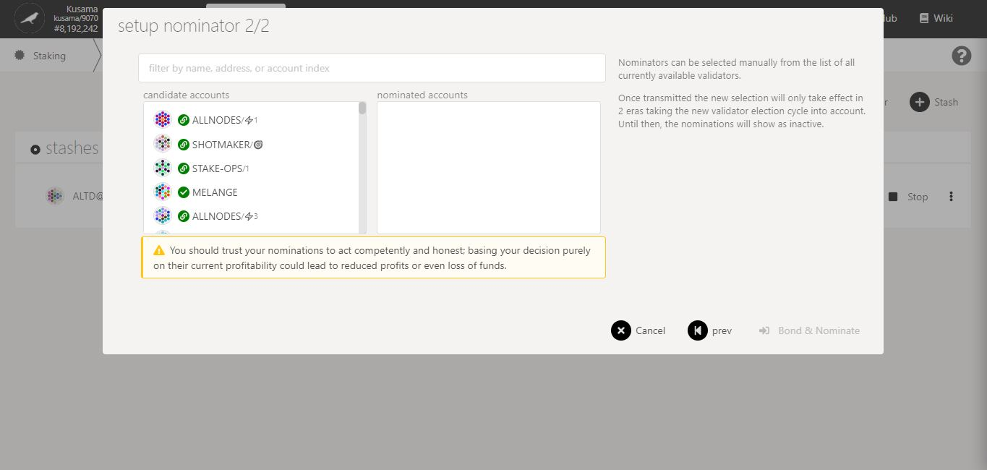

6. Follow the **new instructions** carefully.

7. Double-check **warning messages.**

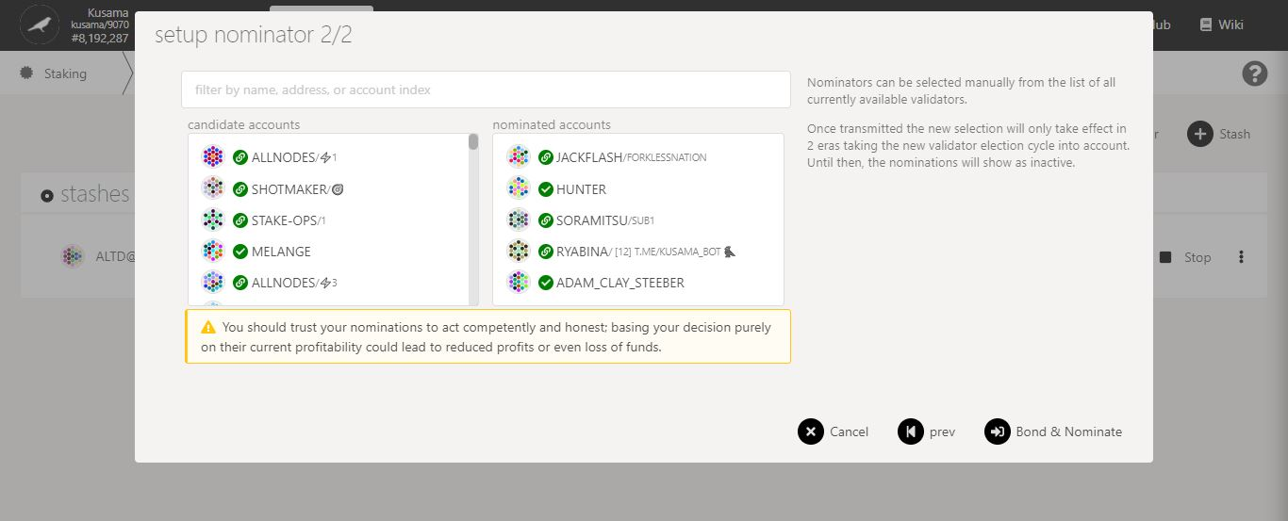

8. Click on **10-16** **validators’ names or addresses** to add them to **your selection**.

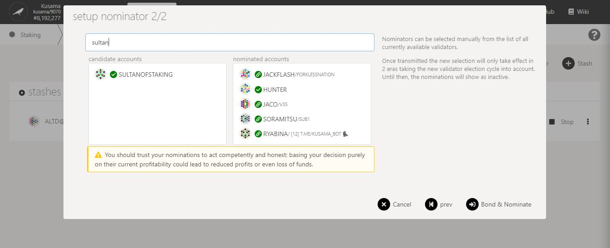

9. You can **search for your favourite validator** to speed up this process.

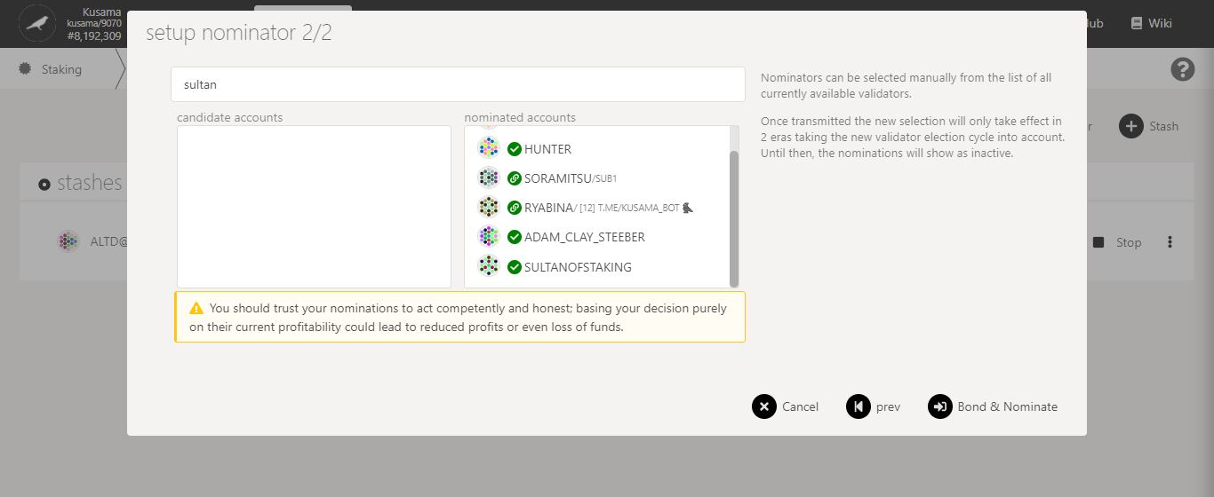

11. Click on **Bond & nominate** to continue the procedure.

10. Double-check your **selection of validators.**

**Nature** of the transaction.

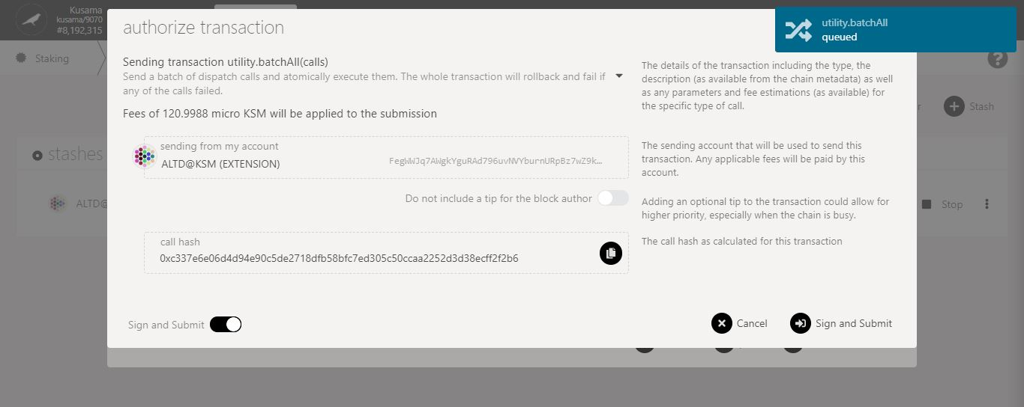

**More validators**

= more nominations

= **higher transaction fees**.

12. Follow the **final instructions** carefully.

13. Click on **Sign & submit** to continue the procedure.

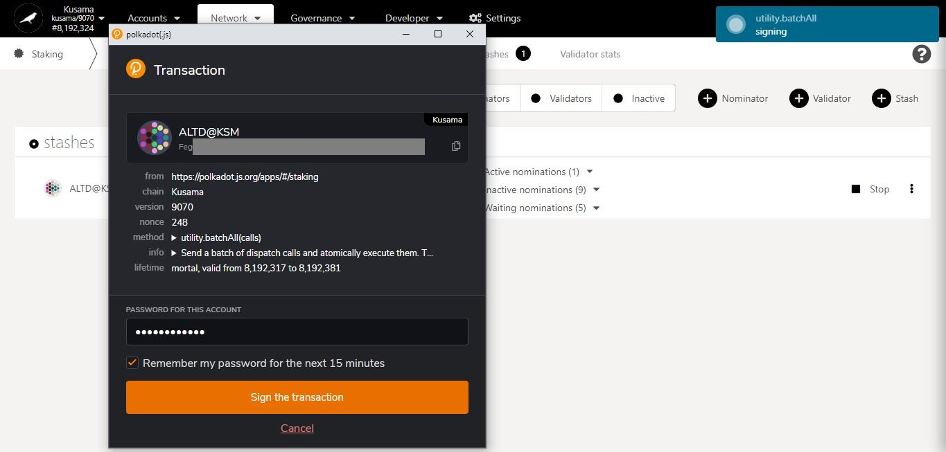

15. Click on **Sign the transaction** to complete the procedure.

14. Enter **your account’s password** and tick the box to **remember your password, if necessary**.

**Summary** of the transaction sent via the Polkadot-JS extension.

**Progress** of the transaction.

* **Add stashes.**

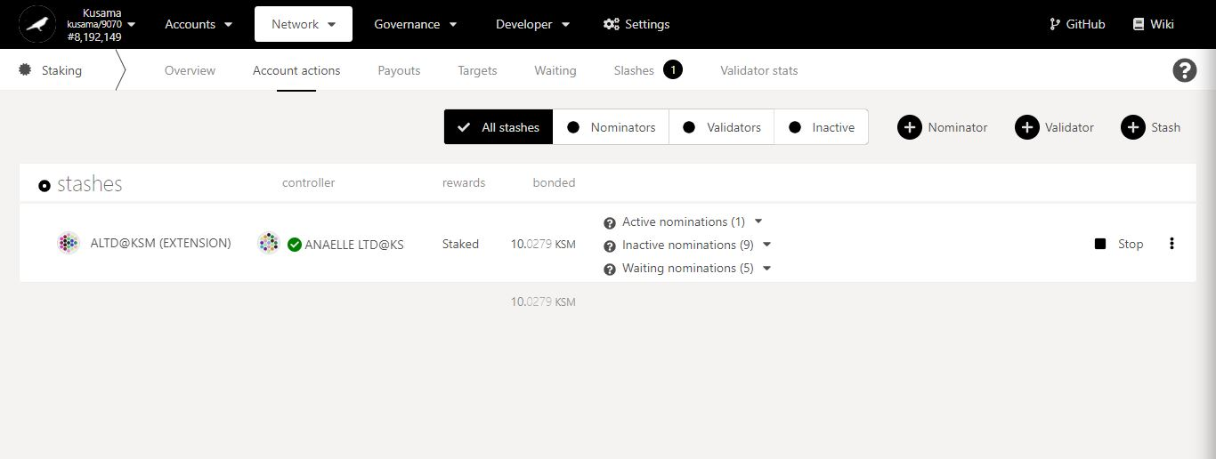

1. Click **Stash**.

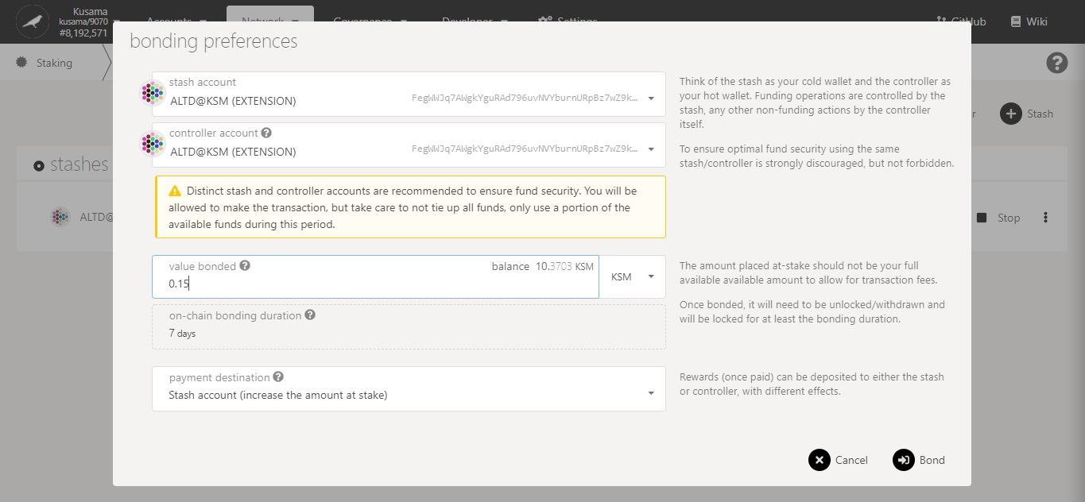

4. Click on **Bond** to continue the procedure.

3. Double-check **warning messages.**

2. Follow **on-screen instructions** carefully.

**Nature** of the transaction.

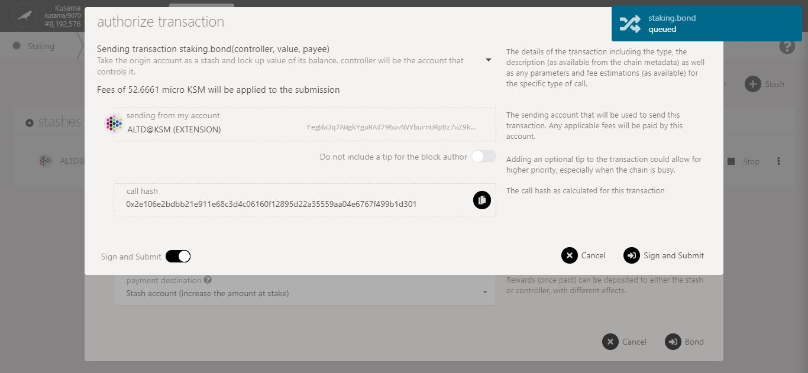

5. Check the **transaction fees**.

6. Click on **Sign & submit** to continue the procedure.

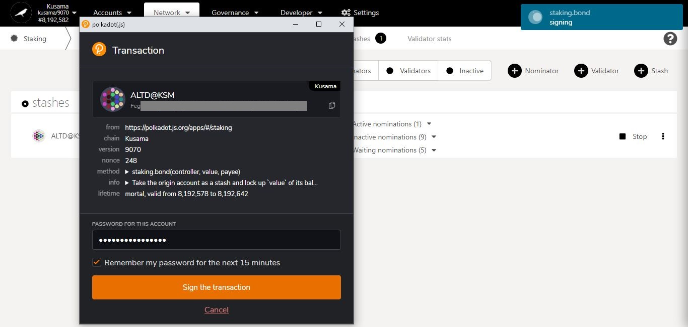

**Summary** of the transaction sent via the Polkadot-JS extension.

8. Click on **Sign the transaction** to complete the procedure.

7. Enter **your account’s password** and tick the box to **remember your password, if necessary**.

**Progress** of the transaction.

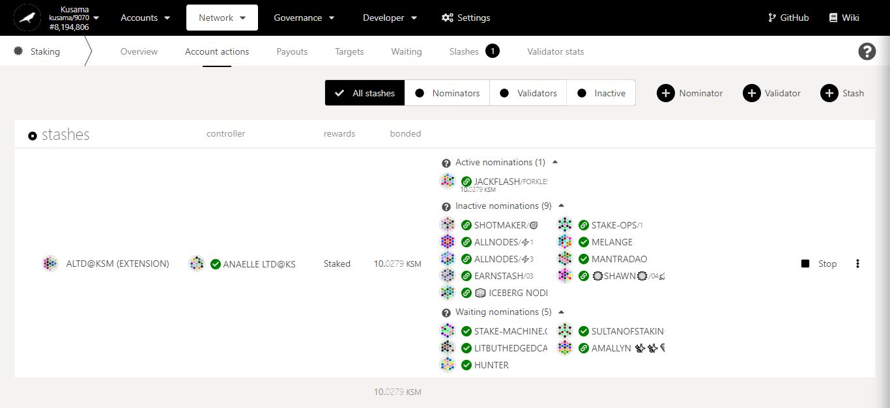

Staking summary:

**Staked:** Total balance of KSM bonded/locked into nominations (includes rewards payouts if paid are made into stash).

**Active nominations:** Nominated validator that is in the active set and making reward payments for the current era.

**Inactive nominations:** Nominated validators that are in the active set but not making rewards payments for the current era.

**Waiting nominations:** Nominations waiting to be included in the active set or in the list of rewardees.

Stop all **nomination activities associated with this stash.**

Name of **the controller**.

It is used to **set nominees for bonded KSM on behalf of a stash**.

Name of **the stash**.

It is used to **bond KSM for nominations and set a controller.**

It can be used **to compound reward payouts.**

**View** all the stashes associated to your existing accounts.

* **Bond more funds.**



1. Click on the 3 vertical dots to view **Staking settings**.

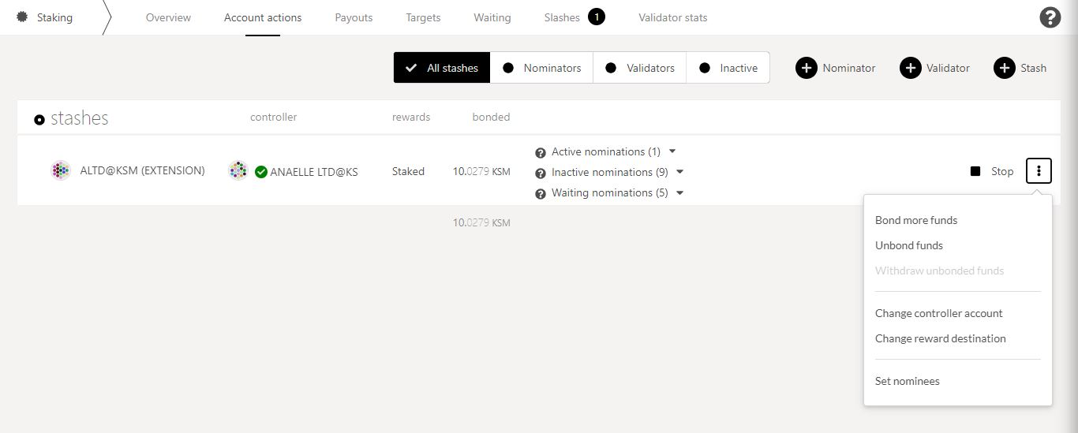

2. Click on **Bond more funds** to increase the amount of KSM you are staking.

3. Follow **on-screen instructions** carefully.

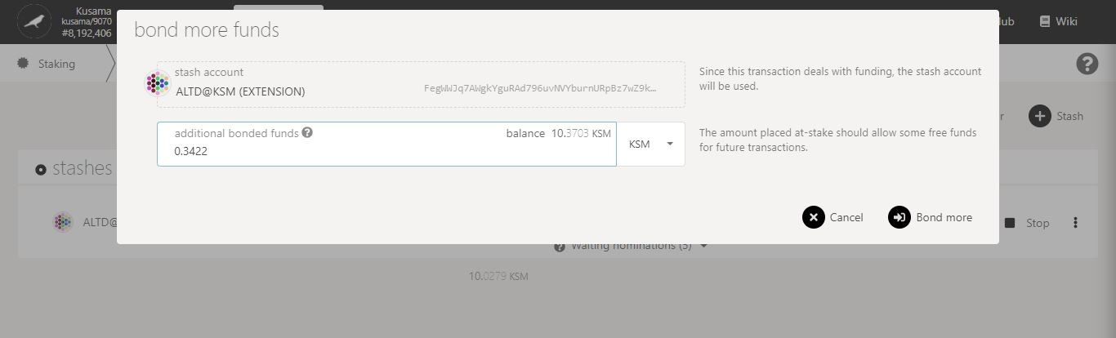

4. Click on **Bond more** to continue the procedure.

**Nature** of the transaction.

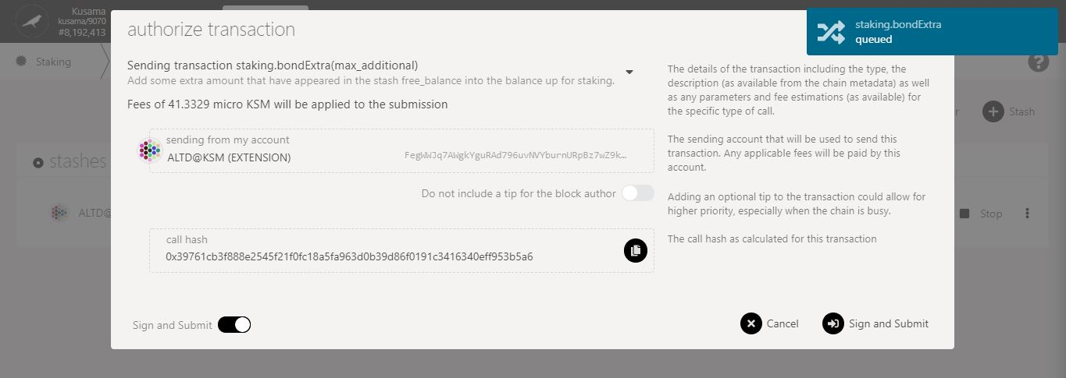

5. Check the **transaction fees**.

6. Click on **Sign & submit** to continue the procedure.

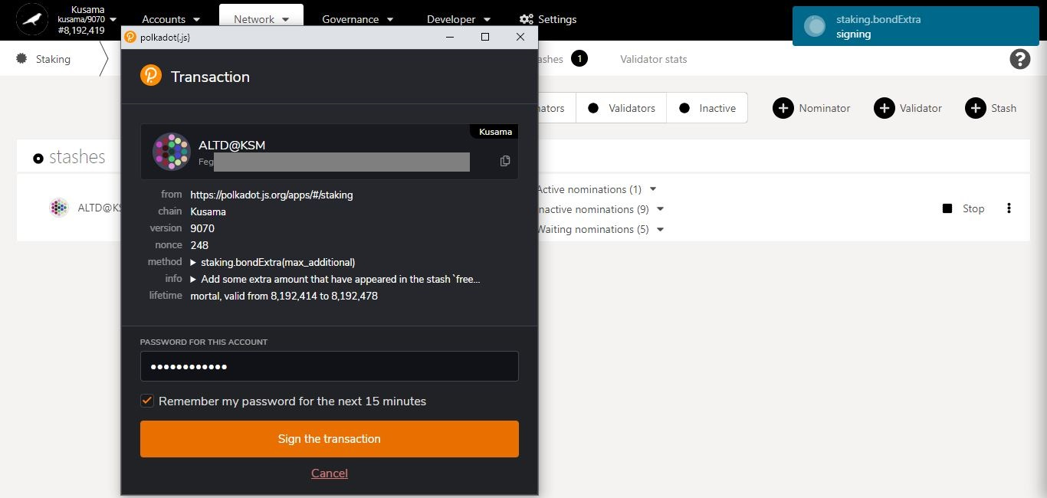

**Summary** of the transaction sent via the Polkadot-JS extension.

8. Click on **Sign the transaction** to complete the procedure.

7. Enter **your account’s password** and tick the box to **remember your password, if necessary**.

**Progress** of the transaction.

* **Unbond funds.**



1. Click on the 3 vertical dots to view **Staking settings**.



2. Click on **Unbond funds** to decrease the amount of KSM you are staking.

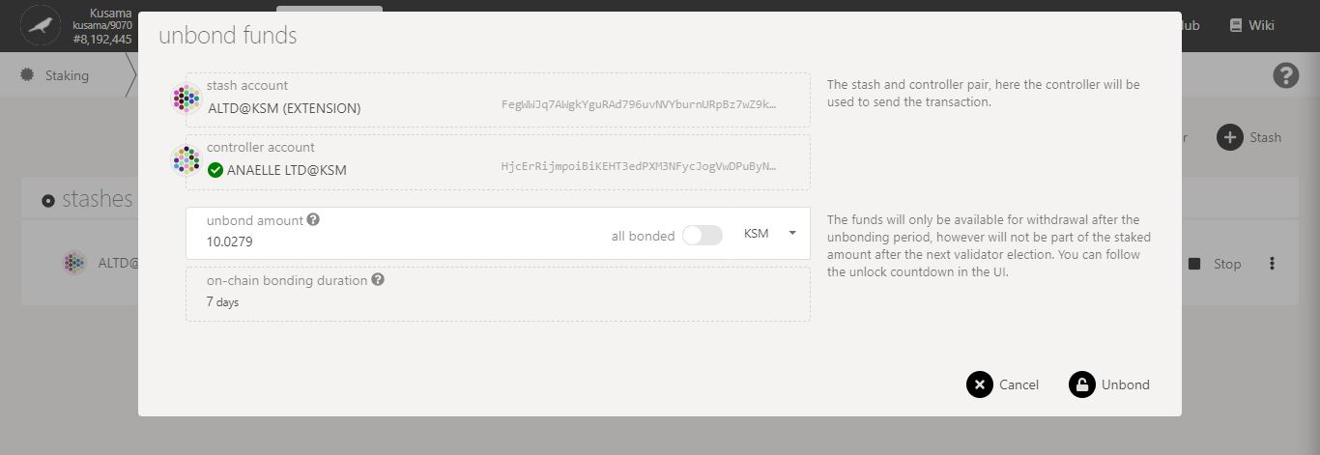

4. Click on **Unbond** to continue the procedure.

3. Follow **on-screen instructions** carefully.

**Nature** of the transaction.

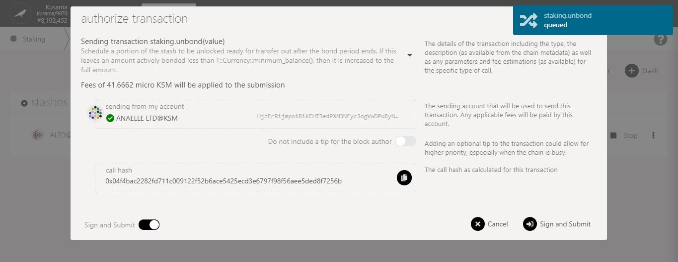

5. Check the **transaction fees**.

6. Click on **Sign & submit** to continue the procedure.

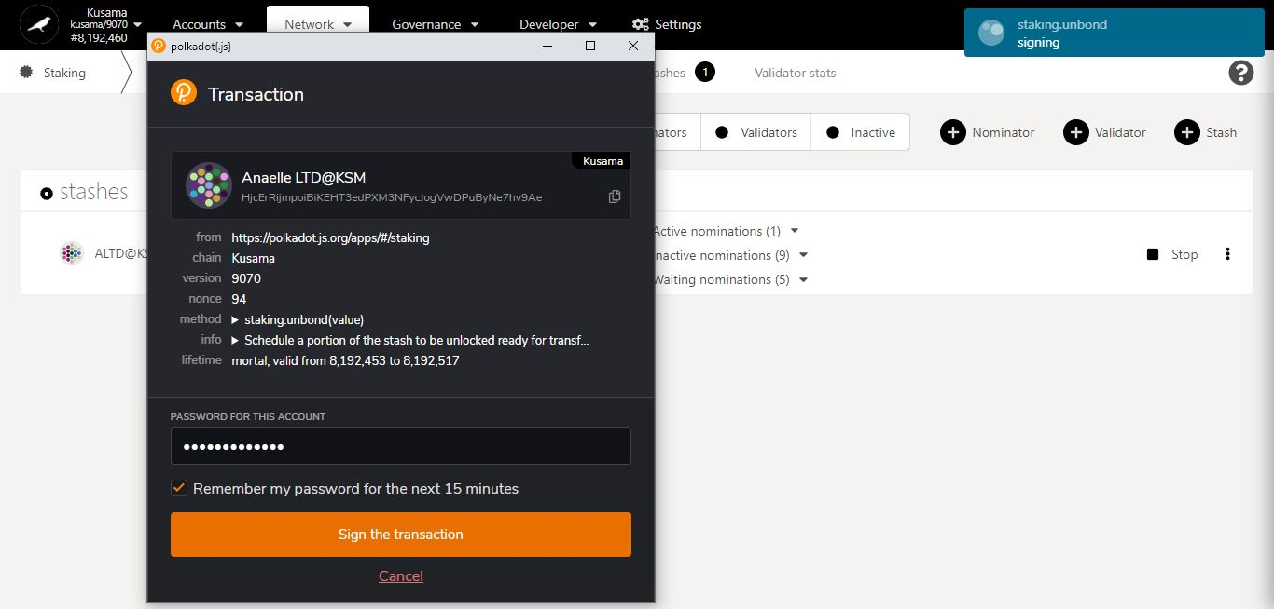

**Summary** of the transaction sent via the Polkadot-JS extension.

8. Click on **Sign the transaction** to complete the procedure.

7. Enter **your account’s password** and tick the box to **remember your password, if necessary**.

**Progress** of the transaction.

* **Change controller account.**



1. Click on the 3 vertical dots to view **Staking settings**.



2. Click on **Change controller account** to set a new controller for this stash.

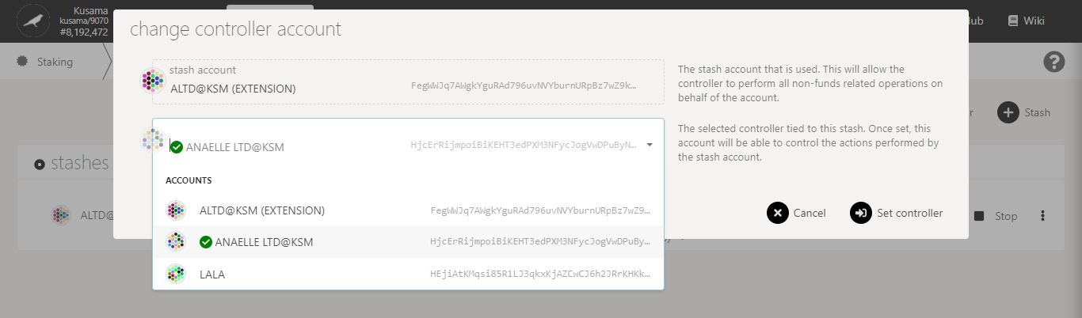

3. Follow **on-screen instructions** carefully.

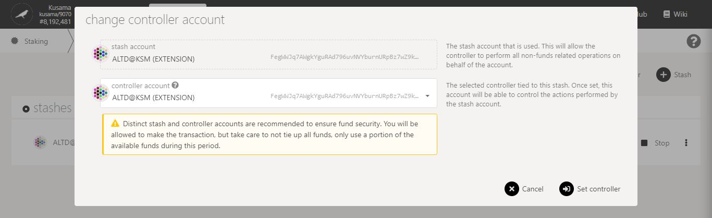

4. Double-check **warning messages.**

5. Click on **Set controller** to continue the procedure.

**Nature** of the transaction.

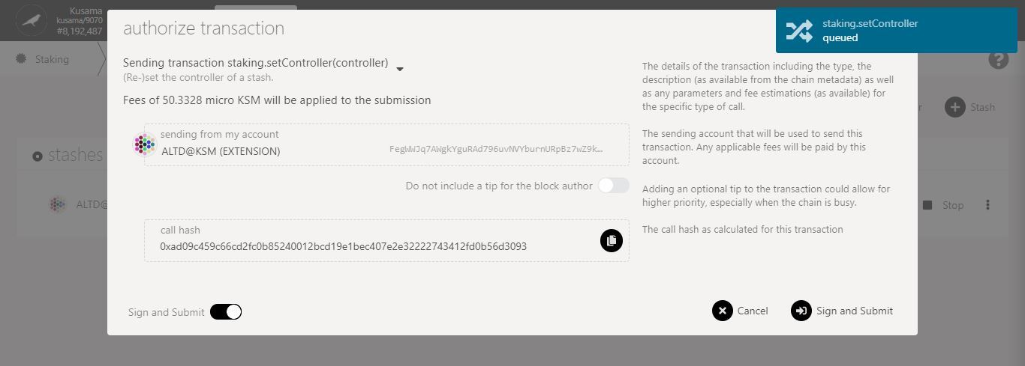

6. Check the **transaction fees**.

7. Click on **Sign & submit** to continue the procedure.

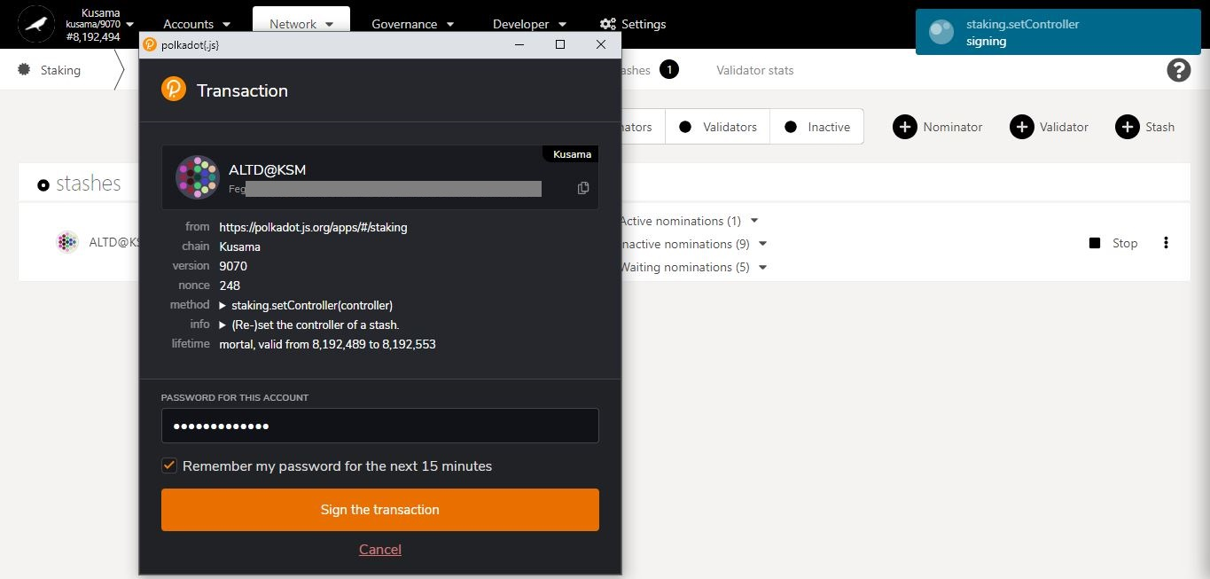

**Summary** of the transaction sent via the Polkadot-JS extension.

9. Click on **Sign the transaction** to complete the procedure.

8. Enter **your account’s password** and tick the box to **remember your password, if necessary**.

**Progress** of the transaction.

* **Change reward destination.**



1. Click on the 3 vertical dots to view **Staking settings**.



2. Click on **Change reward destination** to reset how/where your reward payouts are made.

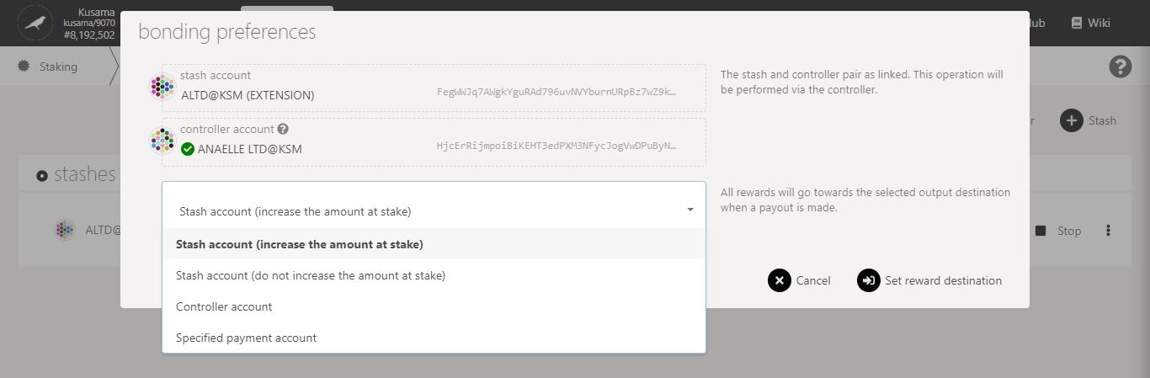

3. Follow **on-screen instructions** carefully.

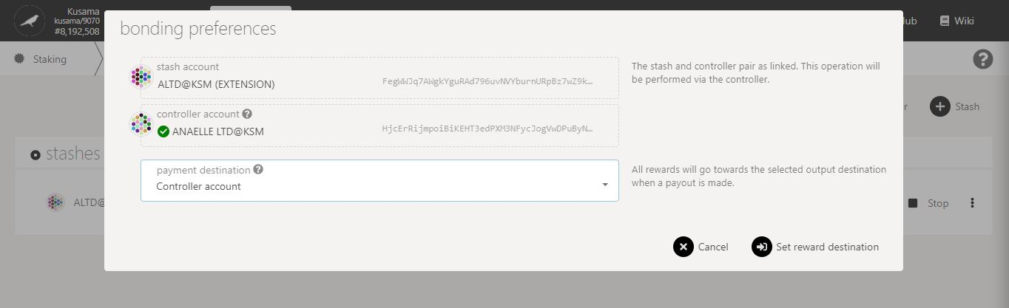

4. Click on **Set reward destination** to continue the procedure.

**Nature** of the transaction.

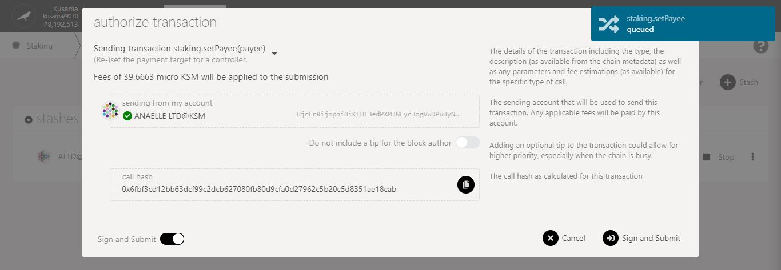

5. Check the **transaction fees**.

6. Click on **Sign & submit** to continue the procedure.

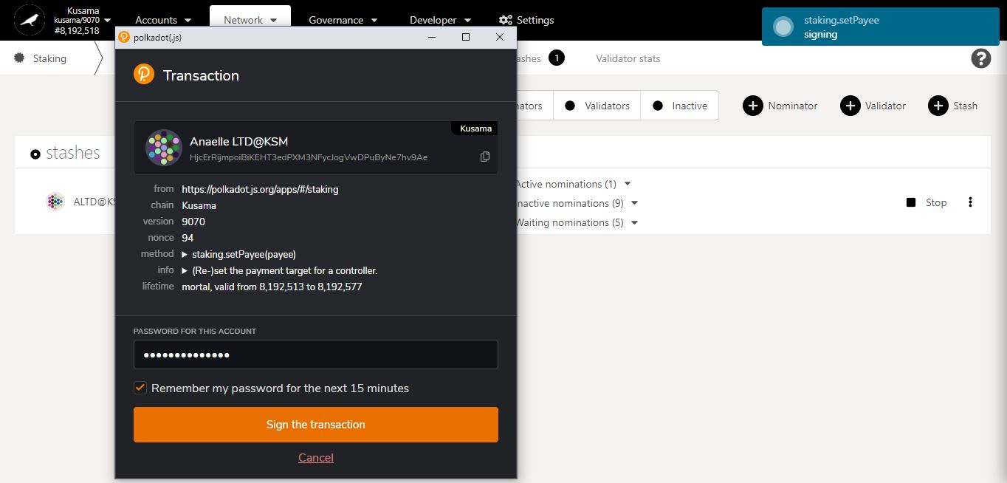

8. Click on **Sign the transaction** to complete the procedure.

**Progress** of the transaction.

7. Enter **your account’s password** and tick the box to **remember your password, if necessary**.

**Summary** of the transaction sent via the Polkadot-JS extension.

* **Set nominees.**



1. Click on the 3 vertical dots to view **Staking settings**.



2. Click on **Set nominees** to change your current selection of validators.

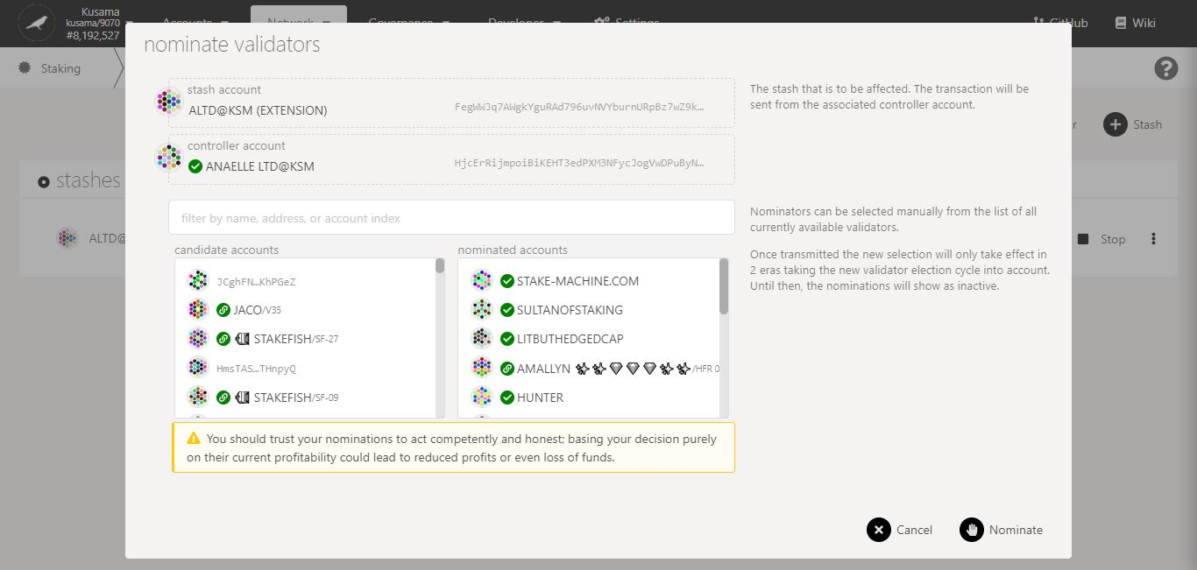

4. Click on **10-16** **validators’ names or addresses** to add them to **your selection**.

5. Double-check **warning messages.**

3. Follow the **new instructions** carefully.

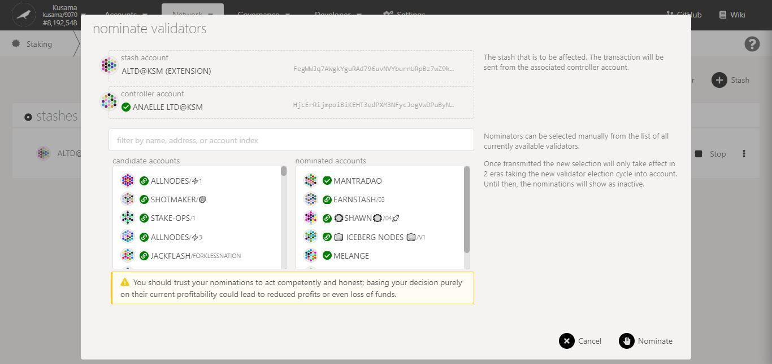

7. Click on **Nominate** to continue the procedure.

6. Double-check your **selection of validators.**

**Nature** of the transaction.

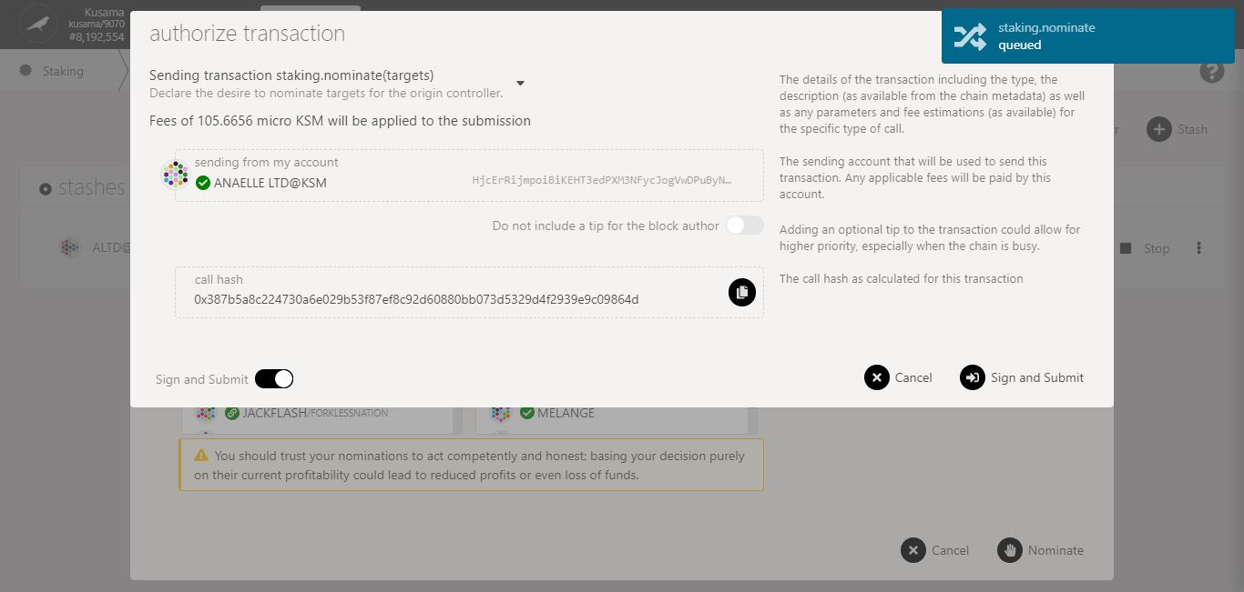

8. Check the **transaction fees**.

9. Click on **Sign & submit** to continue the procedure.

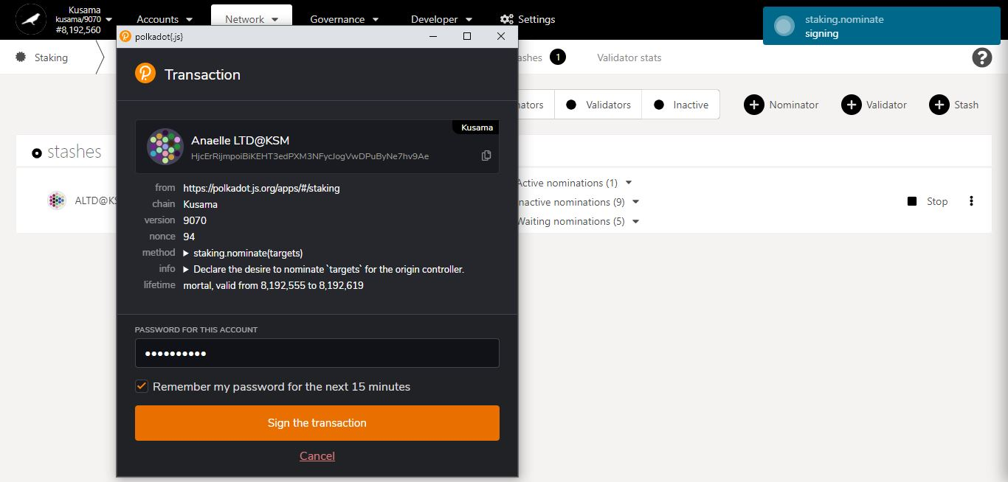

11. Click on **Sign the transaction** to complete the procedure.

**Summary** of the transaction sent via the Polkadot-JS extension.

10. Enter **your account’s password** and tick the box to **remember your password, if necessary**.

**Progress** of the transaction.

* 1. **Check payouts from recent eras.**

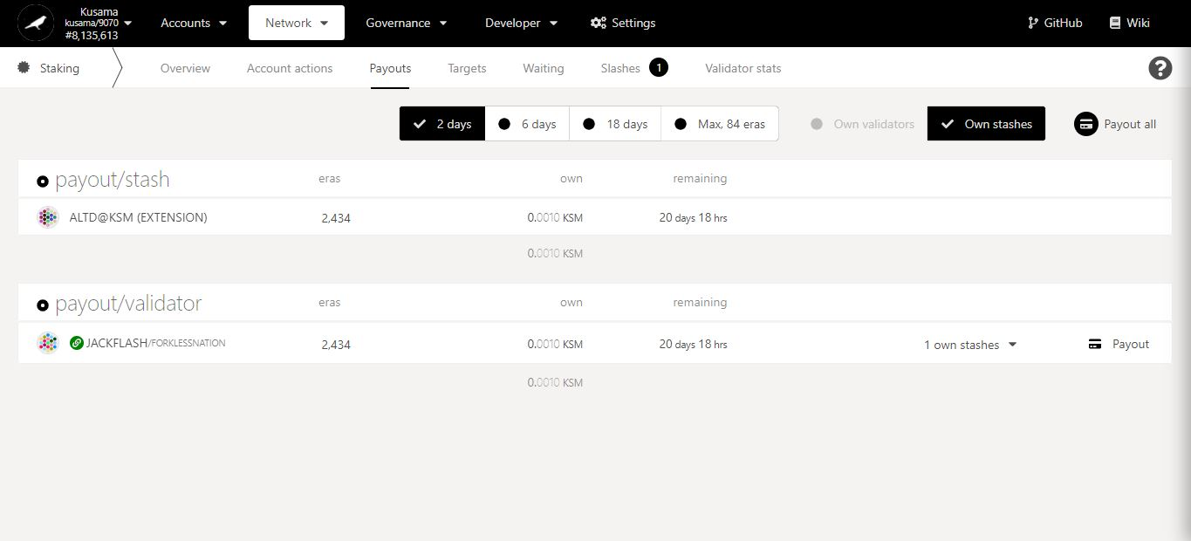

2. Click on **Payout (all)** to immediately receive reward(s) from your validator(s).

1. Click **Payouts**.

Time left for validators to **send the reward payouts**. Note: Most validators will send the reward payouts within a day.

Track all **rewards received and pending** for each individual era.

* 1. **Check nomination targets.**

1. Click **Targets**.

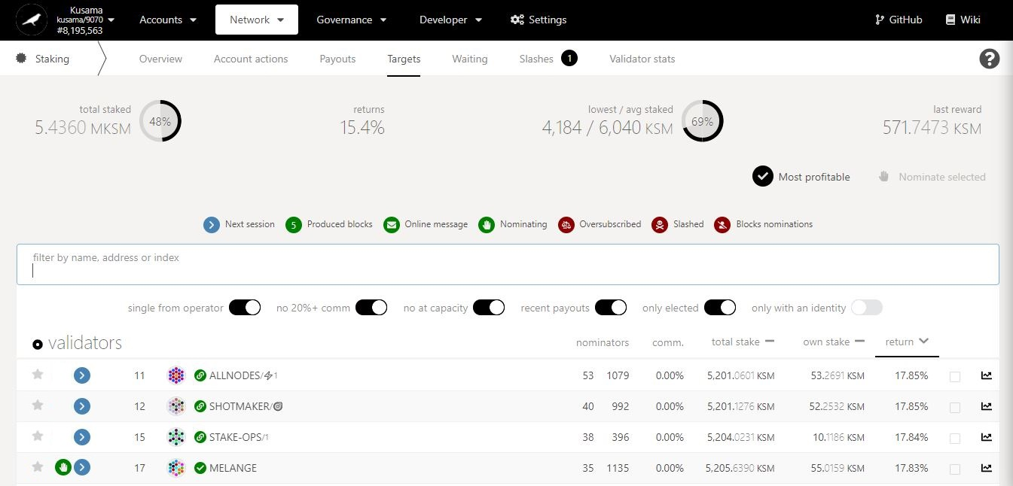

Key information on staking targets: **average returns, amount staked, and amounts rewarded.**

2. Switch the **filters ON** or **OFF** to display your **targeted data.** Ex: You can choose to view only validators who take <20% commission and are not full.

3. Scan through validators’ data and **compare it to your staking targets**.

This validator is in your **current selection of validators**.

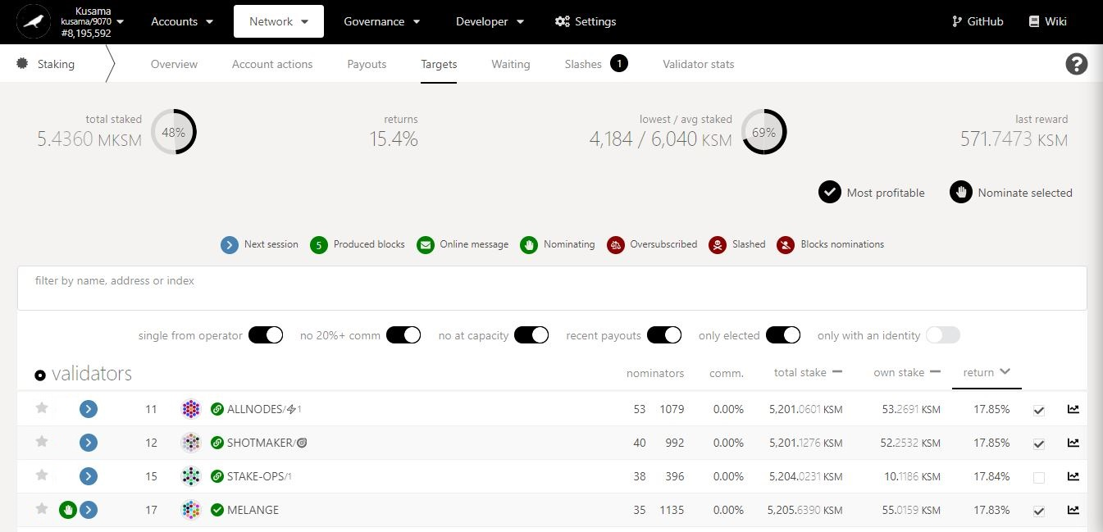

You can click **Most profitable** to **automatically select the top 16 rewarders**.

5. Click on **Nominate selected** to **replace your current list of validators** with a new selection. Note: If you do not select your current active validator, it will be removed!

4. Tick the box to select **10-16 validators that match** your staking targets.

* 1. **Check the list of waiting validators.**

1. Click **Waiting**.

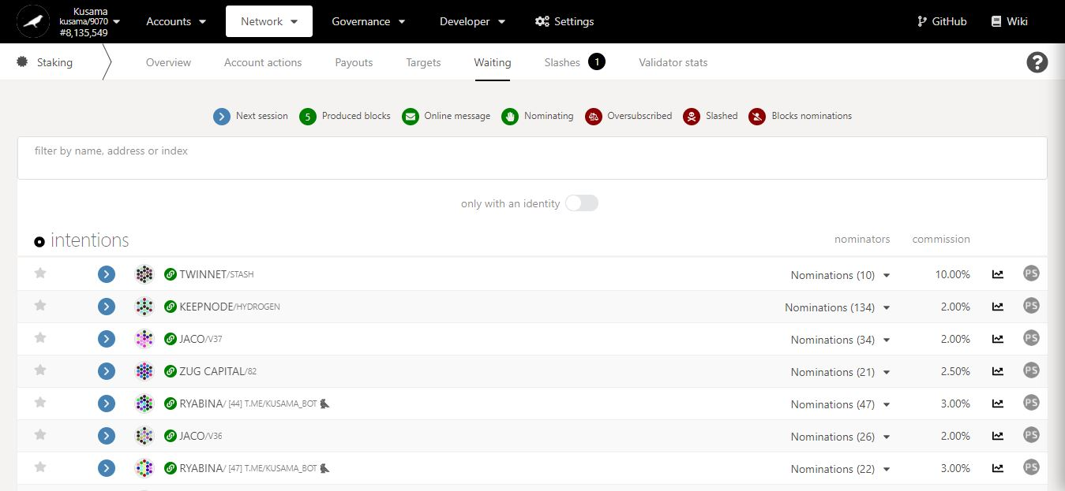

2. Click on **PS** to view a **validator’s statistics**.

Number of nominations **backing each unelected validator**.

* 1. **Check the list of slashed validators.**

1. Click **Slashes**.

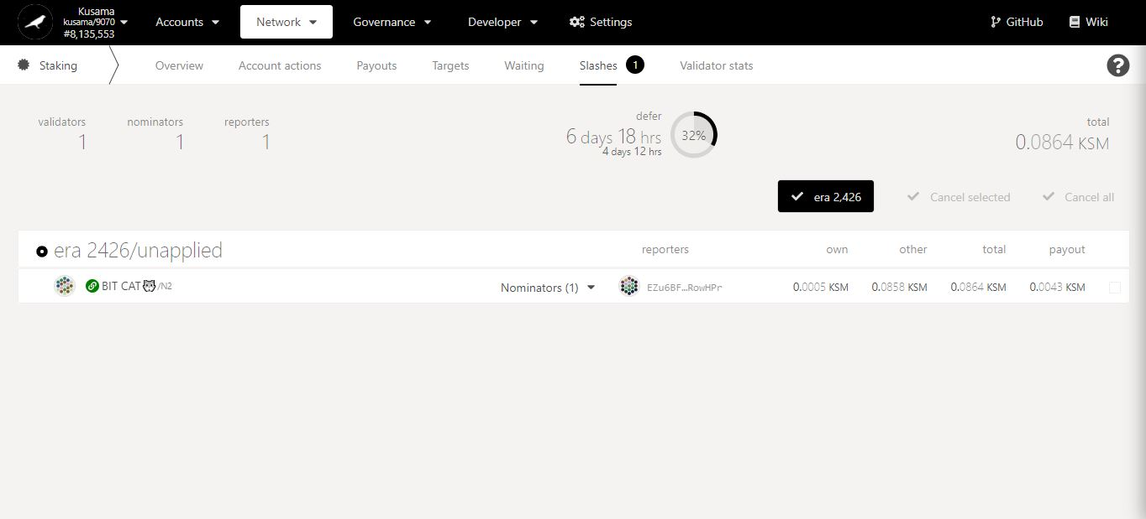

Key information on staking slashes: **validators & nominators concerned, time frames, amount.**

2. Click on the slashed validator’s name to view **a summary of its account.**

3. Click on the dropdown arrow to view **slashed nominators’ information.**

All amount slashed are used to **fund the Treasury**.

* 1. **View individual validator’s statistics.**

1. Click **Validator stats**.

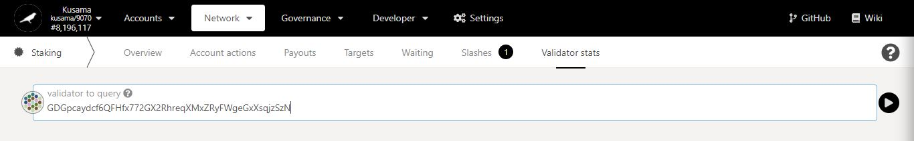

2. Enter/Paste the **address of a validator**, then click the **arrow** to view the validator’s information**.**

**Key validator history:**

- hourly points

- staking amounts

- election status

- rewards & slashes amounts

- commission %.

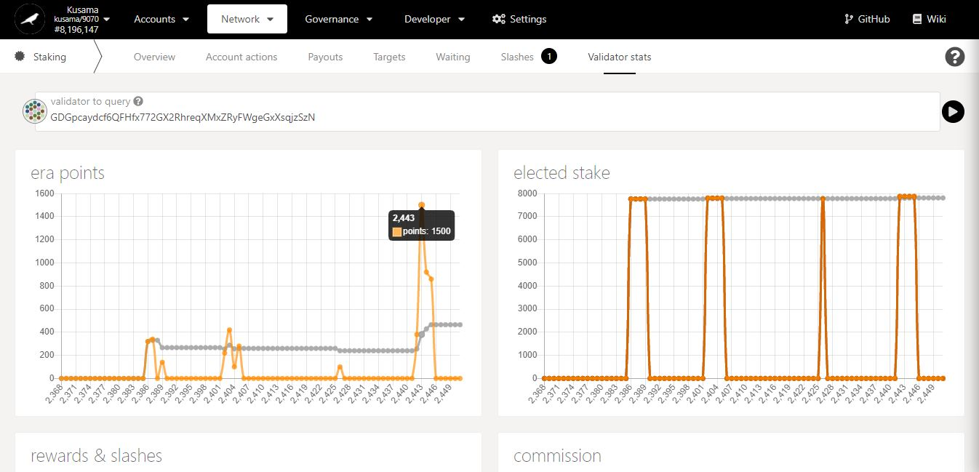

3. Move your mouse along the chart to get **detailed figures**.